**FVHS Student Services**

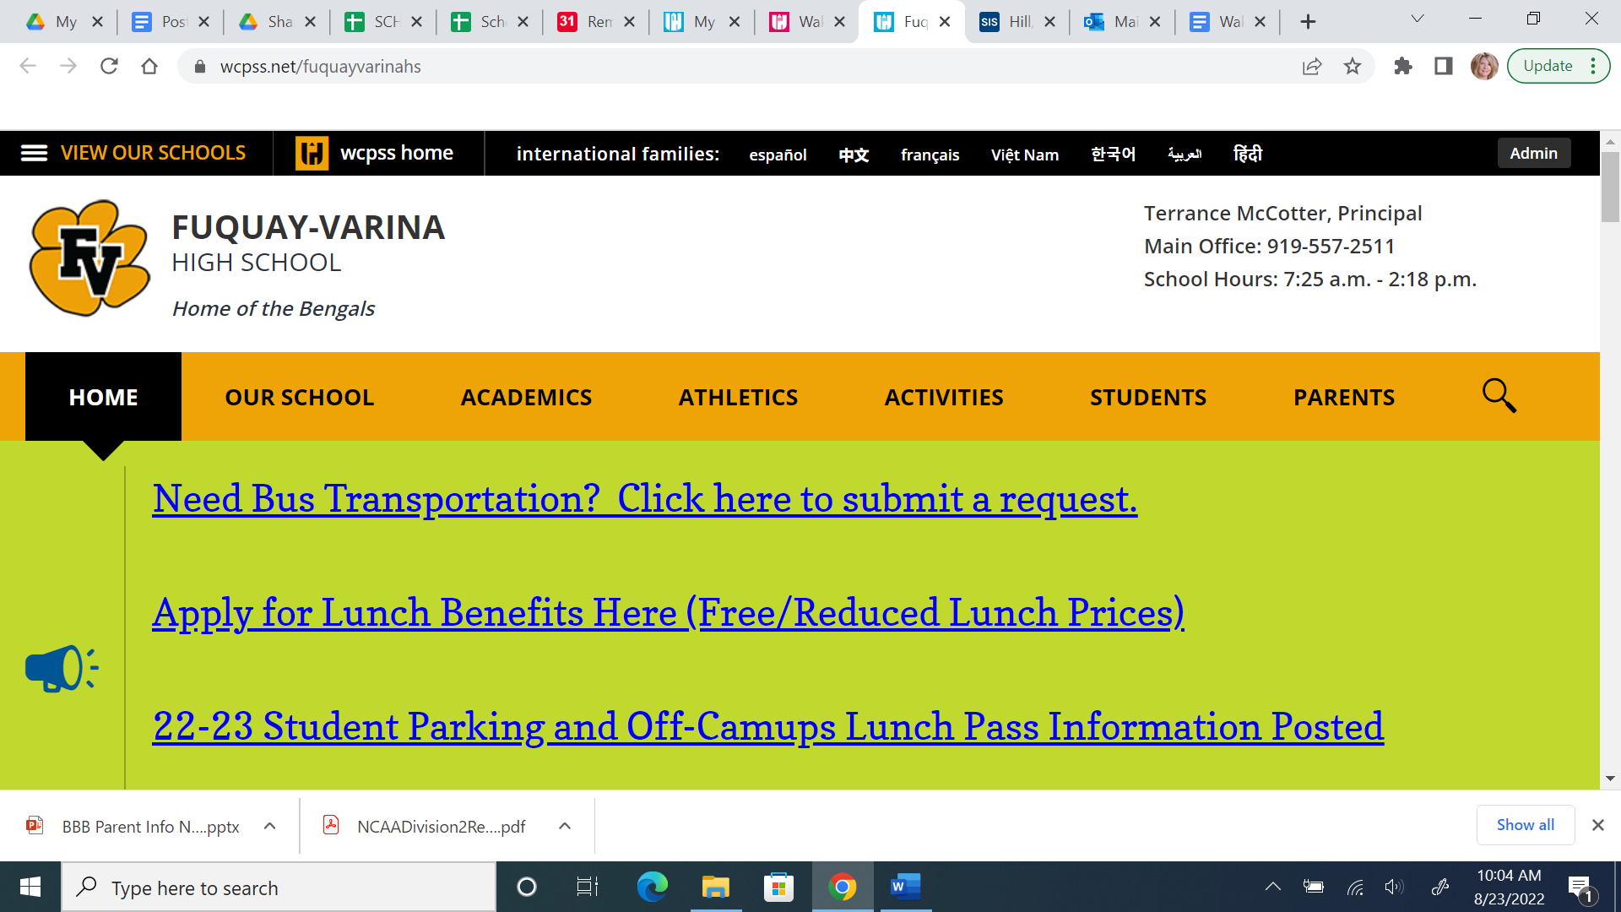

**Main Number: (919) 557-2511**

**Website: fvhsstudentservices.weebly.com**

**Twitter: @FVHSCounselors**

**Receptionist – Tracy Bruining**

[**tbruining@wcpss.net**](mailto:tbruining@wcpss.net)

**ext-23831**

**Registrar – Dana Sobha**

[**dhsobha@wcpss.net**](mailto:dhsobha@wcpss.net)

**ext - 23805**

**Dean - Pat Moore**

[**pmoore1@wcpss.net**](mailto:pmoore1@wcpss.net)

**ext-23837**

**Counselors**

*Students assigned by Last Name*

**To join REMIND, text Counselor’s REMIND CODE to 81010**

**Cu-Hir**

**A-Crr**

**Counselor – Xana Harrington Counselor - Cynthia Wood**

[**aharrington2@wcpss.net**](mailto:aharrington2@wcpss.net)[**cwood6@wcpss.net**](mailto:cwood6@wcpss.net)

**ext-23835 ext-23826**

**Remind Codes: Remind Codes:**

**9th grade: @2026aharr 9th grade: @2026cwood**

**10th grade: @2025aharr 10th grade: @2025cwood  
11th grade: @2024aharr 11th grade: @2024cwood**

**12th grade: @2023aharr 12th grade: @2023cwood**

**Me-Rr**

**Ho-Mcr**

**Counselor -Tricia Myers Counselor - Michelle Montgomery**

[**tmyers1@wcpss.net**](mailto:tmyers1@wcpss.net)[**mmontgomery4@wcpss.net**](mailto:mmontgomery4@wcpss.net)

**ext-23834 ext-23813**

**Remind Codes: Remind Codes:**

**9th grade: @26myers 9th grade: @2026mont**

**10th grade: @25myers 10th grade: @2025mont**

**11th grade: @24myers 11th grade: @2024mont**

**12th grade: @23myers 12th grade: @2023mont**

**A-Zr**

**S-Zr**

**Counselor - Lindsey Kamal SAP Counselor - Beth Fearon**

[**lkamal@wcpss.net**](mailto:lkamal@wcpss.net)[**dfearon@wcpss.net**](mailto:dfearon@wcpss.net)

**ext-23833 ext -23832**

**Remind Codes:**

**9th Grade: @2026kamal**

**10th Grade: @2025kamal**

**11th Grade: @2024kamal**

**12th Grade: @2023kamal**

**Your Checklist for College**

**9th Grade – Set Your Sights on College**

* Take courses that challenge you.
* Explore course options such as AP, honors, and Career and College Promise.
* Create a free CFNC account and explore career interests.

**10th Grade – Keep Your Focus**

* Pursue extracurricular interests, such as dance, sports, clubs, or community service.
* Update your CFNC plan of study. Start using the free SAT and ACT test prep at CFNC.org.
* Look on CFNC.org for free SAT and ACT test prep resources.
* Take the PSAT for practice.
* Use CFNC’s College Search tool to research N.C. colleges.

**11th Grade – The Critical Year for Success**

* Use CFNC.org to find free practice tests for the SAT and ACT.
* Take the PSAT in October (you might qualify for National Merit Scholarships).
* Check admissions requirements of colleges that interest you.
* Attend college fairs and financial aid workshops.
* Visit colleges. Use CFNC.org to start researching scholarships, grants, and loans.
* Talk with coaches about college sports and scholarship eligibility.
* Register and take SAT, ACT, and/or AP tests.
* Narrow down your list of colleges.
* Find a summer job or internship in your field of interest.
* Get a head start on finding money for college. Go to fafsa.ed.gov for a Federal Student Aid Identification (FSA ID) for both you and a parent or guardian. You’ll need them to file your Free Application for Federal Student Aid (FAFSA) early in your senior year. Save these IDs in a secure place and do not share them with anyone else.

**12th Grade – Don’t Let Up**

* Review courses, graduation requirements, and scholarship opportunities with your counselor.
* Take the first SAT or ACT offered this fall.
* Select at least five colleges – a reach school, a safety school, and others in between.
* As soon as possible after October 1, go to fafsa.ed.gov to complete and submit the FAFSA. If you need help with your FAFSA, check CFNC.org for a FAFSA Day event near you or call 866.866.CFNC.
* Participate in College Application Month if offered at your school.
* Keep track of the application and financial aid deadlines of your college choices.
* Check with college financial aid offices for school-specific scholarship information, deadlines, and forms.
* Write, edit, proofread, and rewrite your admissions essays early.
* Ask teachers, counselors, or community leaders to write recommendation letters to support your applications.
* Use NCResidency.org to determine eligibility for in-state tuition and state grants.
* Use the CFNC.org online application system to complete your N.C. college and university applications and to send your official transcripts (if you attend an N.C. public high school).
* Submit any applications to out-of-state schools through their websites.
* If you are a student athlete, send transcripts to NCAA Clearinghouse for eligibility certification.
* Finish Strong Compare admission acceptance letters and financial aid pack
* Compare admission acceptance letters and financial aid packages.
* Apply for education loans, if needed. Limit the amount you borrow; you will have to pay it back.
* Send in your enrollment deposit to hold your spot at the college you choose.
* If not accepted by your college of choice, use the College Redirection module at CFNC.org for new options.
* Make sure your final high school transcript is sent to your college (goes automatically if you requested one through CFNC.org earlier).
* Take exams for any AP or college-level courses completed.